BELUGA NECROPSY REPORT
ID Number: _____________________
Location: __________ (Lat;Long)__ ______________
Reported by: _ _____________________ Contact info:_ ___________________
Date found: __________Date recovered: __________Necropsy Date: _____
Species: beluga (D. leucas) Age: Sex: M F Unknown
Prosectors: Contact info: _________________________
Weather info:____________________________________________________________
Human Interaction Forms?__; Chain of custody forms:_ ; Level A forms filled out:__ BRIEF HISTORY:

GROSS DIAGNOSIS:

MEASUREMENTS (cm unless indicated)
Tooth count: Total ______ UpL _____ Up R _____ Low L _____ Low R_____
Diameter / length largest tooth
Basic Measurements | Value | Basic Measurements* | Value
Total length (9) |  | Skin thickness
snout to center of blowhole (4) |  | Blubber thickness, dorsal bdf (w/o skin) straight down from caudal end of dorsal ridge, 45° from spine.
Center of BH to Dorsal ridge (18) |  | Blubber thickness, dorsal midline Axillary (w/o skin)
Girth, anus (17an) |  | Blubber thickness, ventral midline Axillary (w/o skin)
Girth at axilla (17ax) |  | Blubber thickness, lateral Axillary, (w/o skin)
Fluke width (15) |  | Weight of the Epaxial L1-12
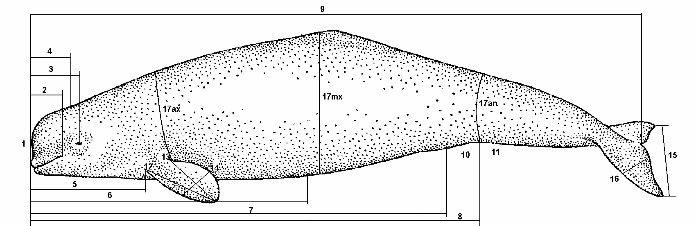
BDF

Axillary

Blubber depth sites

EXTERNAL EXAMINATION (CIRCLE)
CARCASS CLASSIFICATION: |  | BODY CONDITION:
Code 2 Fresh |  | 1 Robust
Code 2.5 mild decomposition |  | 2 Good
Code 3 moderate (decomposed organs intact) |  | 3 Average
Code 4 Poor (advance decomposition) |  | 4 Poor
Code 5 Mummified |  | 5 Emaciated
GROSS NECROPSY FINDINGS:
PHYSICAL EXAM (general condition, lesions, deformities, appearance, color):
PHOTO of Overall Left lateral _____ Right lateral _____ Dorsal _______ Ventral ______ Dorsal Ridge _______Flank fullness _______ Cd-R Tail shot” _________ Fluke shot ________
Open mouth shot _________ if abnormal Grey Scale standard __________

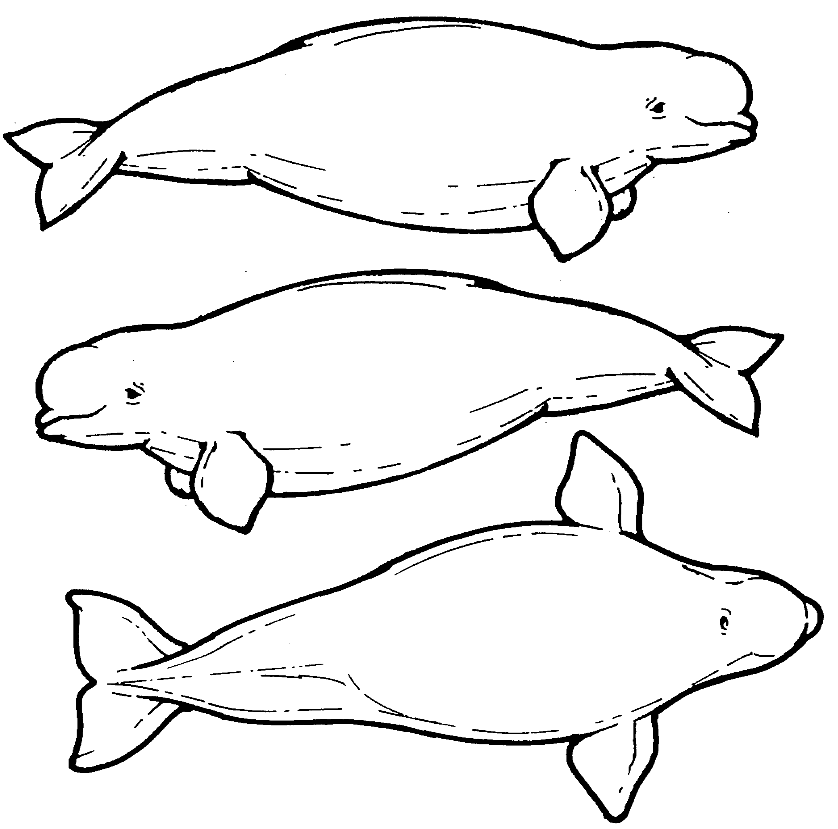
Dorsal ridge collection

SQ:

MUSCULOSKELETAL (color of muscle, appearance of joint fluid:
Weight of L1-L12 epaxial muscle ______

BODY CAVITIES:
Peritoneal Cavity (Abdomen): FLUID?

Pleural (Chest) cavity: FLUID?

RESPIRATORY (foam, fluid, texture and color of lungs, parasites? – don’t forget the sinuses and blowhole). Is the fat band at the back of the lungs thick?
If young, check to see if the lung Floats.
Lung Right: __________g Left: ___________g

CARDIOVASCULAR:

Whole Heart Mass __________g; RV mass ___________g; LV/ IVS mass __________g
RAV___________cm; PA ____________cm; LAV ___________cm; AoV ___________cm;
RV ___________cm; IVS _____________cm; LV _____________cm
ENDOCRINE:
Adrenals: Right : __________g Left : ___________g

Thyroid: Right : __________g Left : _______g

URINARY: is there fat around the kidneys? Location of live worms: _______________
Kidney Right: __________g # of Nodules _______ weight of nodules _____________g
Left: ___________g # of Nodules _______ weight of nodules _______________g

LIVER: (bile, parasites, color, texture)
Liver_____________g

DIGESTIVE: (serosal surface, content, mucosal surface, parasites): TEETH PHOTO

REPRODUCTIVE: (measure (weight and LXDXH) ovaries, uterine horns, placenta if present):

Left uterine horn: _____x_____x_____; Right uterine horn: _____x_____x_____;
Right ovary: _____x_____x_____; __________g; left ovary _____x_____x_____; _________g
Weight of testes and epididymus: ________________g
Placenta______________g ____X _____X_____cm

NERVOUS:

CARCASS DISPOSITION:
COMMENTS (CAUSE OF DEATH, INTERPRETATIONS):

HOW DID YOU TAKE YOUR TOXICOLOGY SAMPLES?:
Circle: Ziplocs / Foil / Acetone-cleaned Foil / Teflon / Whirlpak / I-Chem jars
Type of gloves (circle): Nitrile, latex, other Powder free / powdered.

ESTIMATE THE AGE BY LENGTH: From Vos 2019 (updated 2022) females with an estimated age of less than seven years and males with an estimated age of less than eight years were coded as juvenile
________________________________________________________________________________________________________ 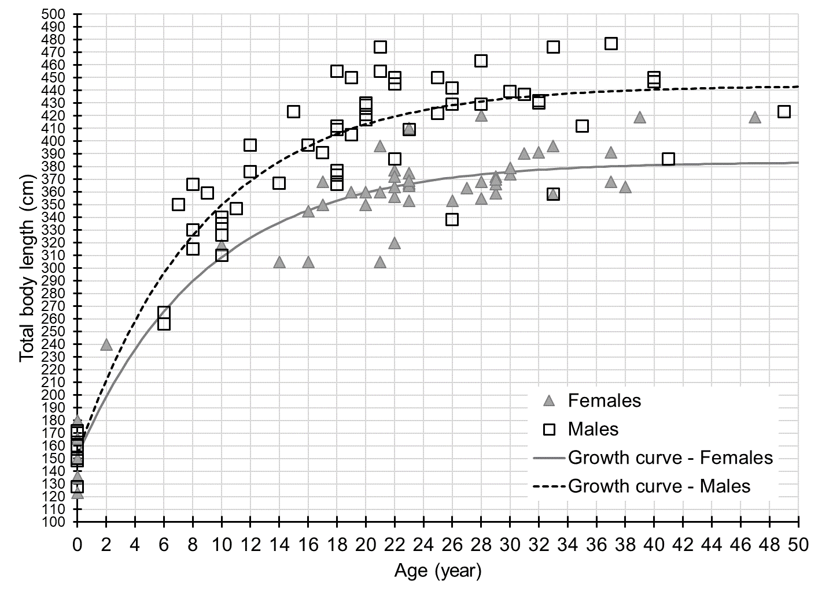
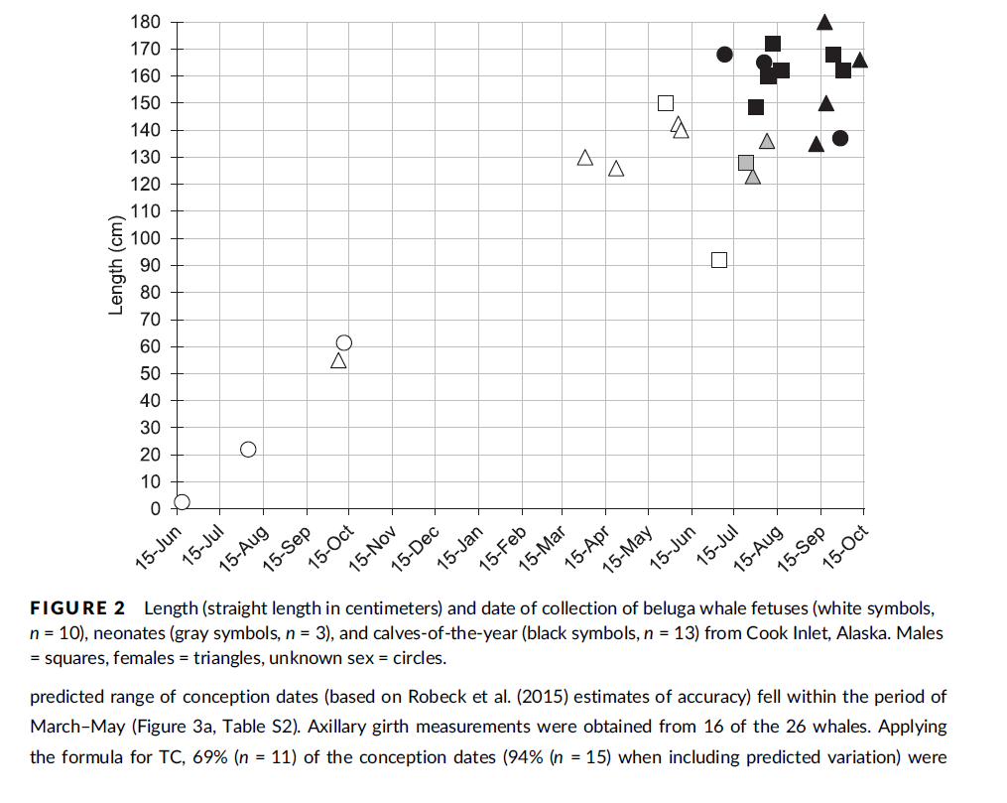
from Shelden et al. 2019 Breeding and calving seasonality in CIB Fetus vs neonates vs YOY
latex vinyl powder-free nitrile
