Gray Whale Gross NECROPSY Notes (UME version - last edited 10/16/2020)
ID Number: _____________________
Location: __________ (Lat;Long)________________
Reported by: _________________ Contact info:________________________________
Date found: _____________Date recovered: __________Necropsy Date: _____
Species: Age: Sex: M F Unknown
Prosectors: _____________ Contact info: _________________________
Weather info:____________________________________________________________
Human Interaction Forms? ; Chain of custody forms: ; Level A forms filled out

BRIEF HISTORY:
-Have there been reports of vessel strike in the past week? -What active fisheries are present in the area, and what gear type is used? Where on the whale’s body could this interaction have occurred?

GROSS DIAGNOSES:

MINIMAL MEASUREMENTS (cm unless indicated)
Basic Measurements | Value | Basic Measurements* | Value
Total length |  | Skin thickness
Girth at axilla (armpit level) |  | Blubber thickness, lateral Max Girth (w/o skin)
Girth, anus |  | Blubber thickness, dorsal midline Axillary (w/o skin)
Fluke width |  | Blubber thickness, ventral midline Axillary (w/o skin)
 |  | Blubber thickness, lateral Axillary, (w/o skin)

Suggested Length Category Cut-offs (updated 9/14/20 NR)
Calf <7- 8m (supported by short baleen < 25 cms at longest plate, small barnacles)
Yearling = 8-9m (but consider other features such as baleen length, larger barnacles, strand location, and time of year)
Subadult = 9-11.1m (males); 9-11.7m (females)
Adult >11.1m males; >11.7m females

EXTERNAL EXAMINATION (CIRCLE)
CARCASS CLASSIFICATION:
Code 2 Fresh
Code 2.5 mild decomposition
Code 3 moderate (decomposed organs intact)
Code 4 Poor (advance decomposition)
Code 5 Mummified

Appendix I - Example Nutritional Body Condition Status Score (Please check off what fits best with as much as possible)
No | External / Internal | Feature | 1 Emaciated | 2 Thin (Fair) | 3 Average (Moderate) | 4 Fat (Good/Excellent) | CBD
1 | External | Nuchal fat pad area | Marked dipping | Slight dip | Flat | Convex
2 | External | Vertebral processes | Prominent processes | Shape detectable | Not visible | Very rounded profile
3 | External | Epaxial muscle profile (thoracic and lumbar) | Sharply concave musculature | Slight dipping of the epaxial areas | Flat | Rounded convex (add new photo)
4 | External | Scapulae prominence (Live whales only) | Very visible | Just visible | Not visible | Not visible (see nuchal fat photo above)
5 | Internal | Blubber Characteristics - Blubber Oiliness | Watery or Dry | Low oil | Moderately oil (can see/feel oil but not dripping) | Very oily, oil drips when cut
 | Internal | Blubber Texture | Very fibrous | Moderately fibrous | Somewhat to moderately pliable | Very pliable
6 | Internal | Subcutaneous fat | None | Scant | Moderate | Abundant
7 | Internal | Fat -heart, kidneys, mesentery, omental, mediastinum | None | Scant | Moderate | Abundant
 | Other Features | Y/N/CBD
 | Serous Atrophy of Fat | N
 | Blubber Color? | Y, Salmon color
 | Blubber Red-Band? | Y, Outer-layer band
 | Cyamid load? | Y, Moderate load, head
 | GI Contents? | None
 | GI Parasites? | None
 | Lipid Data? | NA
 | Histologic Nutritional Information | NA
 | Body Shape-Snake-like? | N
 | Overall Score |  |  | 2-Thin (Fair)

GROSS NECROPSY FINDINGS:
PHYSICAL EXAM /INTEGUMENT
- Photos – make notes on the whale outline ALWAYS TAKE AT RIGHT ANGLES!
  - Photograph Right side ____Left side _____Fluke photo_______ knuckles________ Dorsal ______ Ventral __________ Abnormalities___________ Sny previous tag sites __________
  - Photo needs at minimum: ID; measuring device; Date; Site: and which lesion if it is a lesion.
- Morphometrics Minimum is: straight Length:_______Fluke width: ________lateral axillary blubber depth ______ Max girth lateral blubber depth _______axillary girth;____________Girth at anus ____________
- Collect any gear
- Collect aqueous 18g needle and 6-10 ml syringe
- Collect Skin samples – zip, DMSO
- Barnacles, lice – zip
- If enough people, collect the eye – Zip

SQ: Do the blubber depths above
- Collect a 6x6”by full depth skin to muscle or larger at axillary girth DAX or LAX (preferred) or VAX and 6x6”by full depth skin to muscle or larger at maximum girth, lateral
- Cut parallel lines 12 inches apart and flense. If little time, go for the windows over the bladder / colon; liver/stomach for HABs for and back of head for trauma.
- Note any discoloration; softness and investigate those areas more.

SQ notes:

MUSCULOSKELETAL (color of muscle, appearance of joint fluid:
Observe muscle under blubber. If any is darker color, or mushier, or liquid, dissect below here to look for broken bones. Collect broken bones for enforcement. Collect and measure the epaxial muscle at the thoracolumbar junction. Collect epaxial and sternohyoideus for subsampling.

BODY CAVITIES (FLUID?): mediastinal, omental, perirenal, cardiac fat?
Collect pleural or pericardial fluid if not contaminated.

RESPIRATORY (foam, fluid, texture and color of lungs, parasites? – don’t forget the sinuses and blowhole). Is the fat band at the back of the lungs thick?

CARDIOVASCULAR: Collect whole blood; examine all valves if possible.
Blood sites are ventral peduncle, behind eyes, penis after amputating tip.

ENDOCRINE: Collect, measure, weigh if possible
Adrenals:
Thyroid:

URINARY: Collect kidney; Collect urine from bladder (use the window sheet) or
Urine ______ Insert 6 ft. long plastic tube into urethra (cut off the end of the penis in males)

KIDNEY – Collect for subsampling

LIVER: bile from ducts; parasites, Note color, texture.
Collect liver for subsampling.

DIGESTIVE: (serosal surface, content, mucosal surface, parasites):
Open stomachs – buckets or zips or conical tubes to collect

Describe intestinal contents:

Feces – 50 ml conical tubes or Nalgene bottles

Find and collect Colon LN (Just dorsal to colon caudal towards the Exit)

REPRODUCTIVE: put 3” pieces of testis, penis, uterus, whole ovary, in Ziploc. Collect entire cervix if possible, or, photograph

SPECIAL SENSES:
Collect aqueous humor from one eye; then Collect eyes – Whirl-pak 18 oz x 2
Ear plug – in foil, hard container and freeze; 2nd 15% formalin, then 10% NBF

NERVOUS SYTEM:
Brain:
CSF:
Spinal Cord:
Brachial Plexus:
________________________________________________________________________________________________________
CARCASS DISPOSITION:
LIST SAMPLES SUBMITTED IMMEDIATELY AND WHERE

ANCILLARY DIAGNOSTICS:
Photos note who took the photos? CT? Radiographs? MRI?

COMMENTS (CAUSE OF DEATH- WHAT DO YOU THINK HAPPENED?):

HUMAN INTERACTION SAMPLES: BULLETS / FISHING GEAR / OTHER:

HOW DID YOU TAKE YOUR TOXICOLOGY SAMPLES?
Circle: Ziplocs / Foil / Acetone-cleaned Foil / Teflon / Whirlpak / I-Chem jars
Other______________________________ Rinsed tissues with: ______________________________
Type of gloves (circle): latex vinyl powder-free nitrile

SUB-SAMPLING (asap upon return): Keep all samples cool not frozen, subsample into clean containers.
Once sub-sampled and repackaged, label each container with
Animal ID #; date; sample type. If possible, DOUBLE Label
Fluids:
- Aqueous humor: Place 1ml aliquots in cryovials and 2 5mls.
- Blood: Centrifuge whole blood from 2 tubes, separate serum, place in 1 ml aliquots in cryovials (ONLY If super fresh)
- Urine: Place 5 ml cryovials
- Feces: Place in clean 50 ml Centrifuge tubes in 100g aliquots.
- Bile – Bile: - distribute to an Amber vial and 5 ml cryovials
- Pleural and pericardial fluids - 5 ml cryovials
Freeze all fluids -80 C if possible, otherwise -20 C

Tissues:
- Skin: 1 piece 1 mm cube into DMSO vials (for genetics)
- Lesions, skin, lung, heart, kidney, spleen, liver, tongue, intestine, lymph nodes, repro tract, muscle:
  - 1 cm cube in 10% formalin (all in 1 jar, ensure 10 times as much formalin as total tissue)
  - 1 cm cube in Whirlpak frozen at -80 C ideal, -20 C OK
- Bones: Freeze large pieces at -20 C. Small splinters add to formalin jar above
- Ear plug: Place in jar 15 % formalin, change to 10% formalin after 1 week
- Blubber:
  - LAX and LMAX: Cut 1x1x full thickness and fix in 10% NBF
  - LAX and LMAX: Cut 1x1x full thickness wrap in foil and freeze
  - Other blubbers: Cut clean cube 4” wide from internal sample, wrap in foil, place in Ziploc, freeze -20 C
- Muscle: Thoracolumbar sample – measure the area of the piece and record. Put rest in foil and freeze.
- Muscle; Epaxial – blue toped bar coded cryovial for UAM, small whirlpacks for protozoal PCR. Remainder see checklists.
- Muscle: Sternohyoideus – see checklists.
- Parasites: Indicate site collected; Place in 70 % ethanol, Store at room temp.
- Formalin fixed samples: Make sure Pieces are no thicker than 1 cm! and make sure there is enough formalin (20 parts formalin to 1 part tissue!). If there is not, trim and add more formalin / bigger containers.

For more detail, follow checklists.

Separate samples for: Biotoxins, Disease, Toxicology, Life history. See checklists
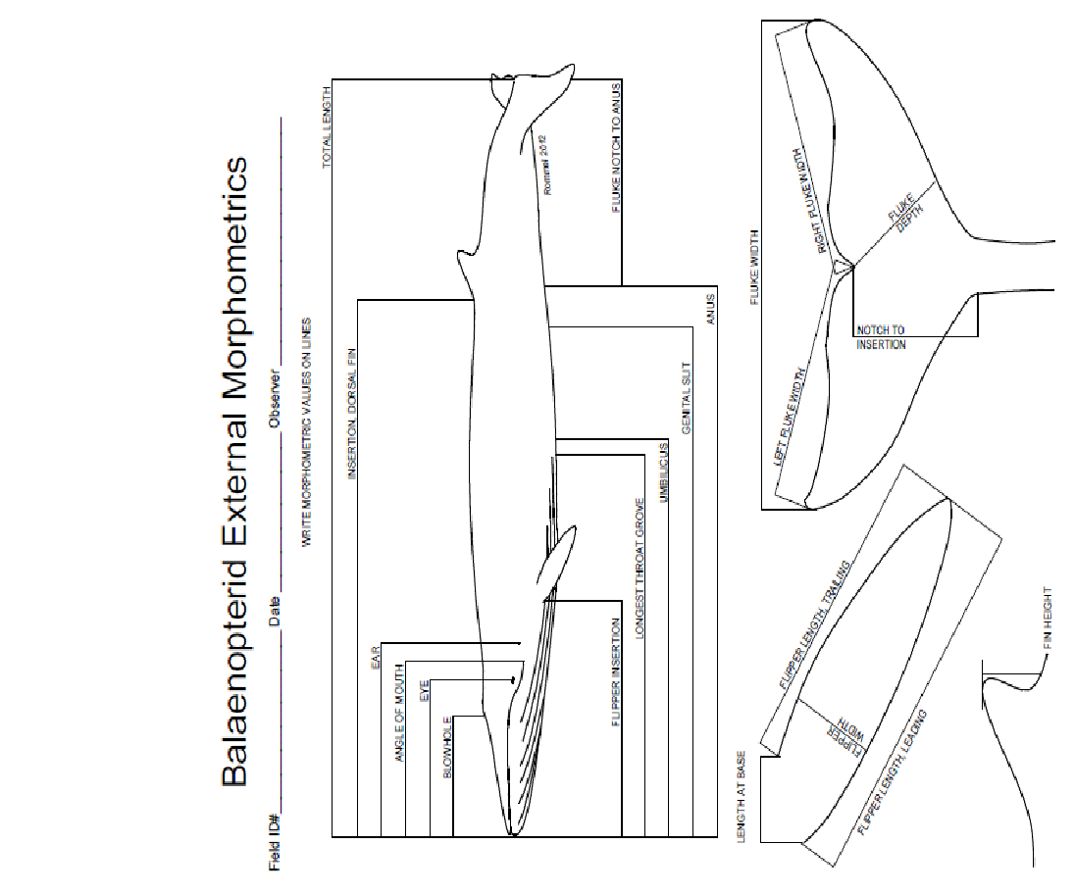
Short lines on whale are Blubber depth sites
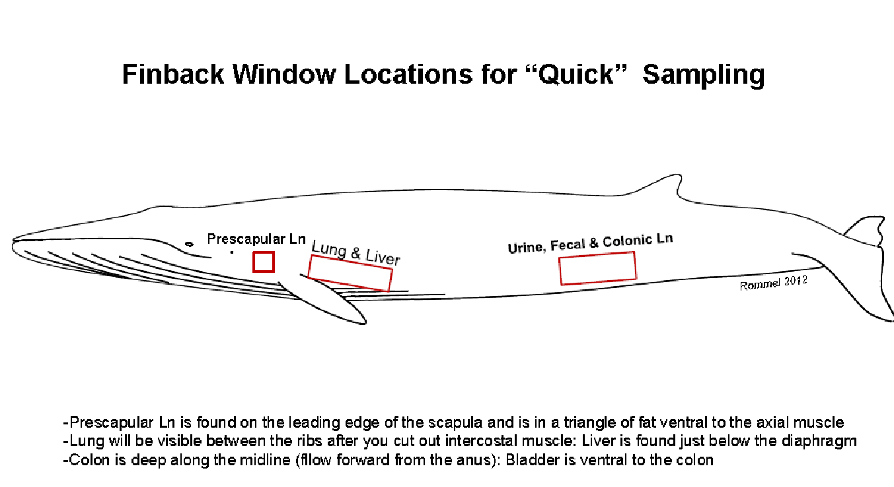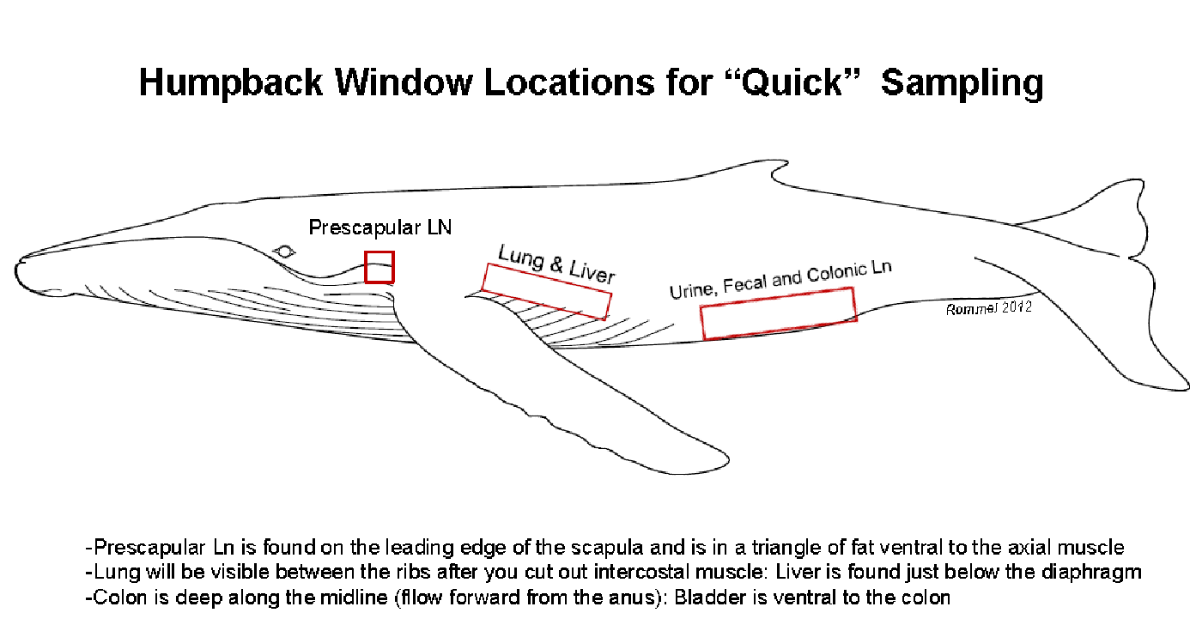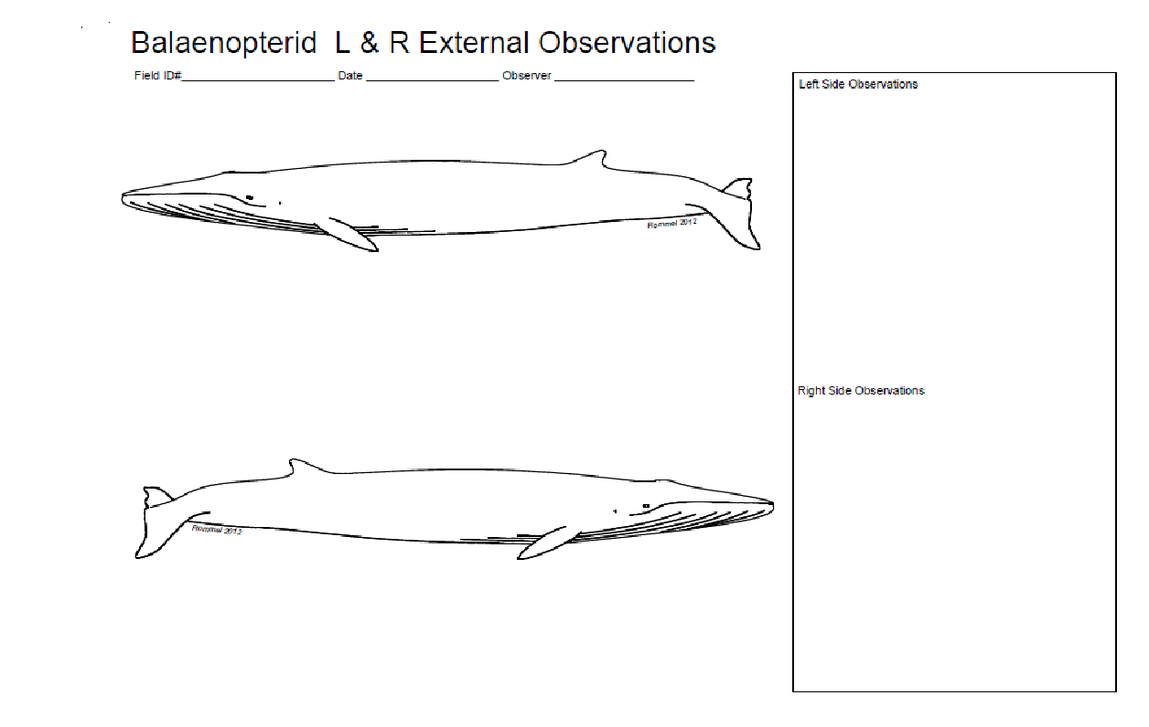
The bars indicate sites of blubber thickness measurement

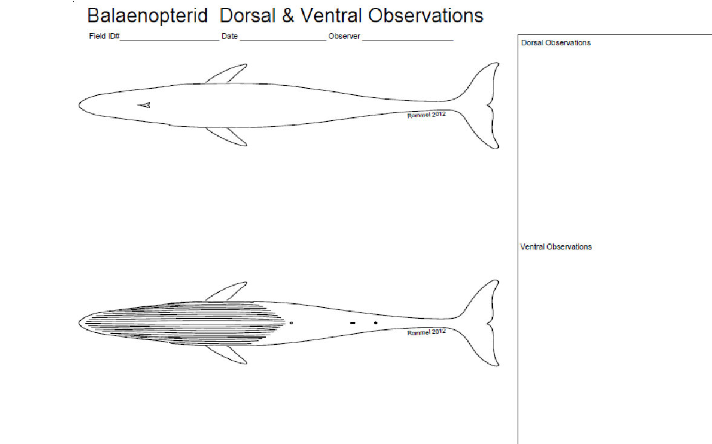
The bars indicate sites of blubber thickness measurement
