BELUGA NECROPSY REPORT
ID Number: _____________________
Location: __________ (Lat;Long)__ ______________
Reported by: _ _____________________ Contact info:_ ___________________
Date found: __________Date recovered: __________Necropsy Date: _____
Species: beluga (D. lecas) Age: Sex: M F Unknown
Prosectors: Contact info: _________________________
Weather info:____________________________________________________________
Human Interaction Forms? ◻; Chain of custody forms: ◻; Level A forms filled out ◻ BRIEF HISTORY:

GROSS DIAGNOSIS:

MEASUREMENTS (cm unless indicated)
Tooth count: Total ______ UpL _____ Up R _____ Low L _____ Low R_____
Diameter / length largest tooth
Basic Measurements | Value | Basic Measurements* | Value
Total length (9) |  | Skin thickness
snout to center of blowhole (4) |  | Blubber thickness, dorsal bdf (w/o skin) straight down from caudal end of dorsal ridge, 45° from spine.
Center of BH to Dorsal ridge (18) |  | Blubber thickness, dorsal midline Axillary (w/o skin)
Girth, anus (17an) |  | Blubber thickness, ventral midline Axillary (w/o skin)
Girth at axilla (17ax) |  | Blubber thickness, lateral Axillary, (w/o skin)
Fluke width (15) |  | Weight of the Epaxial L1-12
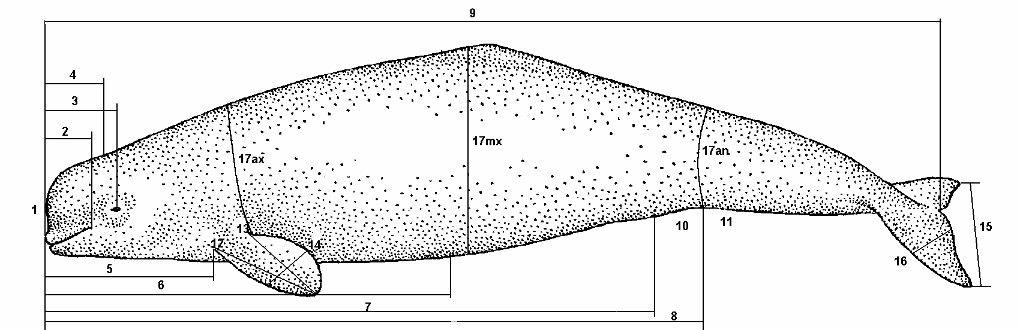

Ax blubber depths

Bdf blubber depth

Blubber depth sites

EXTERNAL EXAMINATION (CIRCLE)
CARCASS CLASSIFICATION: |  | BODY CONDITION:
Code 2 Fresh |  | 1 Robust
Code 2.5 mild decomposition |  | 2 Good
Code 3 moderate (decomposed organs intact) |  | 3 Average
Code 4 Poor (advance decomposition) |  | 4 Poor
Code 5 Mummified |  | 5 Emaciated

GROSS NECROPSY FINDINGS:
PHYSICAL EXAM (general condition, lesions, deformities, appearance, color):
PHOTO of Overall Left lateral _____ Right lateral _____ Dorsal _______ Ventral ______ Dorsal Ridge _______Flank fullness _______ Cd-R Tail shot” _________ Fluke shot ________
Open mouth shot _________ if abnormal Grey Scale standard __________

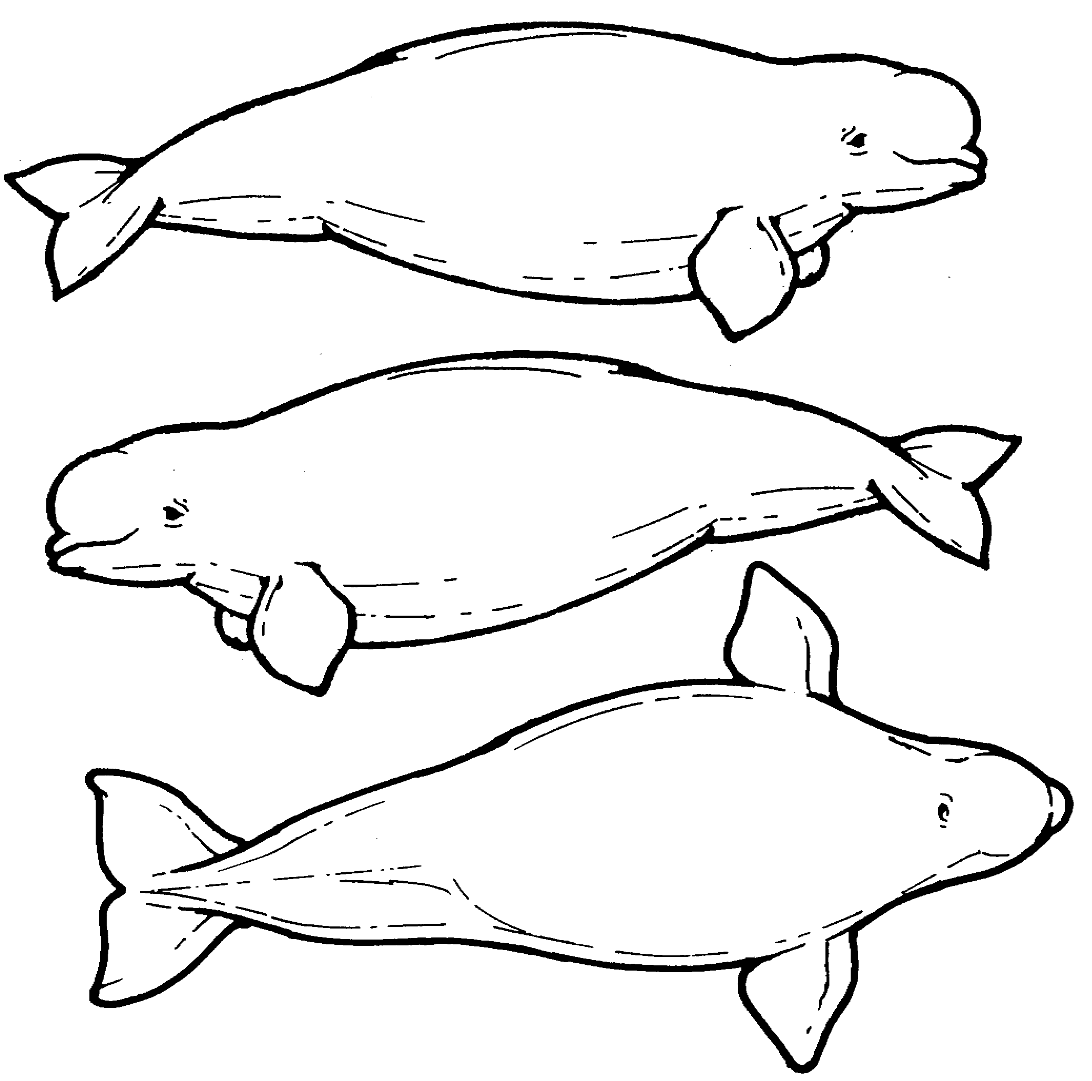
Dorsal ridge collection

SQ:

MUSCULOSKELETAL (color of muscle, appearance of joint fluid:
Weight of L1-L12 epaxial muscle ______

BODY CAVITIES:
Peritoneal Cavity (Abdomen): FLUID?

Pleural (Chest) cavity: FLUID?

RESPIRATORY (foam, fluid, texture and color of lungs, parasites? – don’t forget the sinuses and blowhole). Is the fat band at the back of the lungs thick?
Lung Right: __________g Left: ___________g

CARDIOVASCULAR:

Whole Heart Mass __________g; RV mass ___________g; LV/ IVS mass __________g
RAV___________cm; PA ____________cm; LAV ___________cm; AoV ___________cm;
RV ___________cm; IVS _____________cm; LV _____________cm
ENDOCRINE:
Adrenals: Right : __________g Left : ___________g

Thyroid: Right : __________g Left : _______g

URINARY: is there fat around the kidneys?
Kidney Right: __________g # of Nodules _______ weight of nodules _____________g
Left: ___________g # of Nodules _______ weight of nodules _______________g

LIVER: (bile, parasites, color, texture)
Liver_____________g

DIGESTIVE: (serosal surface, content, mucosal surface, parasites): TEETH PHOTO

REPRODUCTIVE: (measure (weight and LXDXH) ovaries, uterine horns, placenta if present):

Left uterine horn: _____x_____x_____; Right uterine horn: _____x_____x_____;
Right ovary: _____x_____x_____; __________g; left ovary _____x_____x_____; _________g
Weight of testes and epididymus: ________________g
Placenta______________g ____X _____X_____cm

NERVOUS:

________________________________________________________________________________________________________ 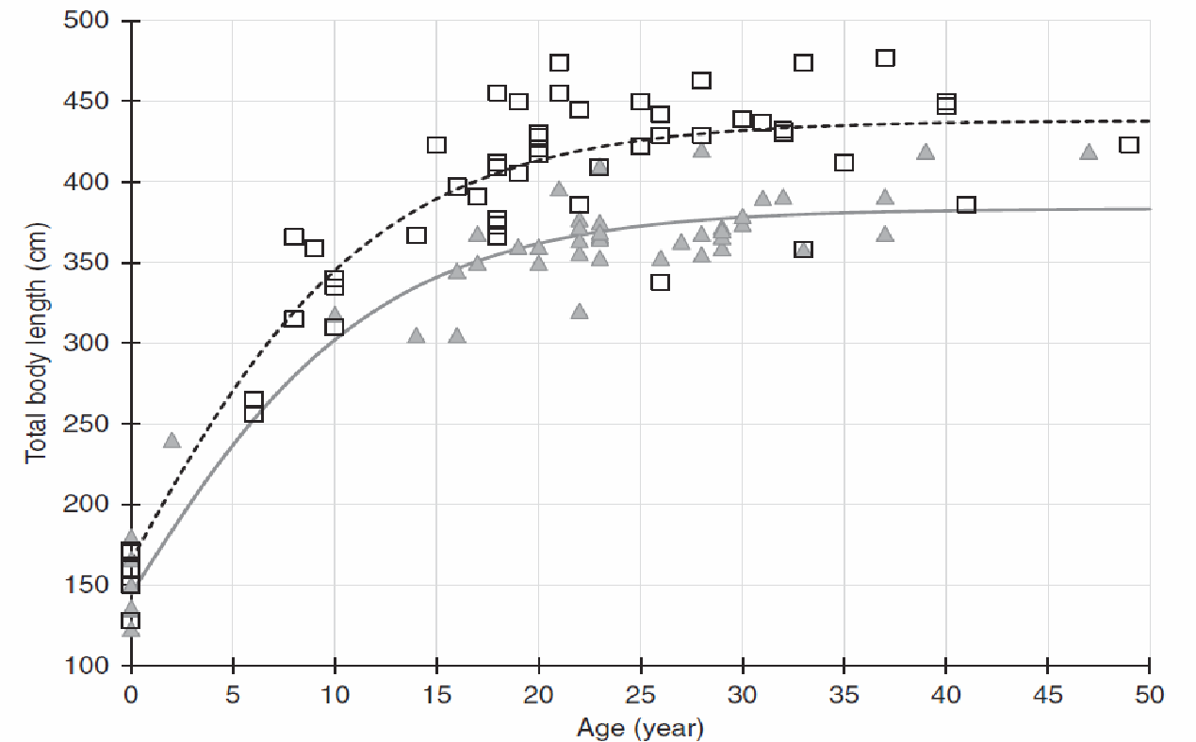
From Vos 2019 females with an estimated age of less than seven years and males with an estimated age of less than eight years were coded as juvenile
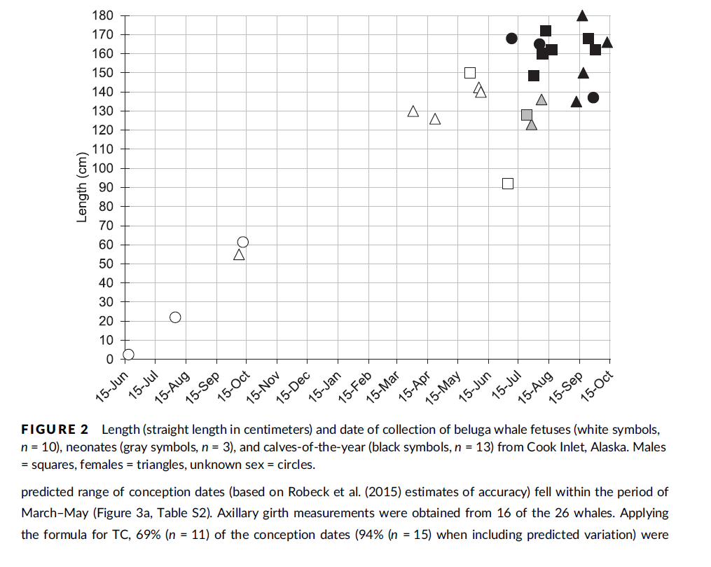
from Shelden et al. 2019 Breeding and calving seasonality in CIB Fetus vs neonates vs YOY

CARCASS DISPOSITION:
COMMENTS (CAUSE OF DEATH, INTERPRETATIONS):

HOW DID YOU TAKE YOUR TOXICOLOGY SAMPLES?:
Circle: Ziplocs / Foil / Acetone-cleaned Foil / Teflon / Whirlpak / I-Chem jars
Other______________________________ Rinsed tissues with: ______________________________
Type of gloves (circle): Nitrile, latex, other Powder free / powdered.
latex vinyl powder-free nitrile
