AGE CATEGORY ESTIMATES
Ringed SEAL (Quakenbush et al., 2011b)
Pup < 1 yr.; Juvenile 1-5 yr; Adult > 5 yr
Pups lose their lanugo around 3 weeks. They nurse for about a month during which time they double their birth weight of 10 lbs (4.5 kg). Adult ringed seals molt from mid-May to mid-July, after each breeding season.
Females give birth to a single pup in a snow lair on the landfast ice or pack ice during March and April and nurse their pups for five to seven weeks. Mating generally occurs in the water one month after females have given birth
https://www.biologicaldiversity.org/species/mammals/bearded_ringed_and_spotted_seals/ringed_seal_natural_history.html#:~:text=BREEDING%3A%20Females%20give%20birth%20to,after%20females%20have%20given%20birth.
Ringed seal - Neonate 0.6-0.7 m 4-4.5 kg; Weaning 0.8 m 9-16 kg; Adult 1.2-1.5 m 60-100 kg
Error bars are 1 SD
Body condition indices for ringed seals (Quakenbush 2011)

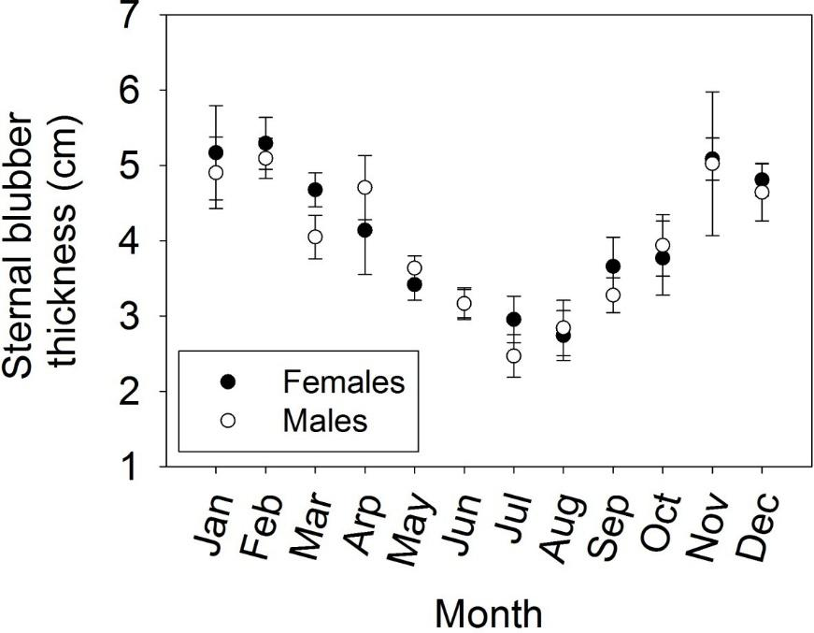

Figure 13. Seasonal variability in mean sternal blubber thickness of subadult and adult ringed seals, all years combined. Error bars represent 95% confidence limits.
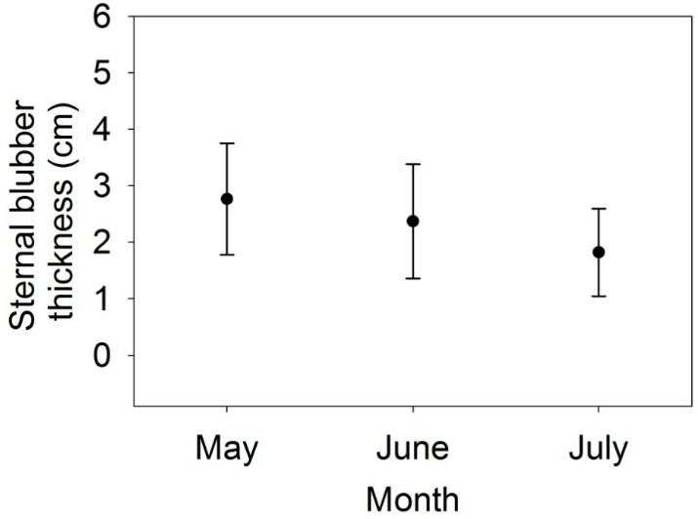

Figure 16. Average sternal blubber thickness by month for ringed seal pups. Error bars are 1 SD.

RIBBON SEAL (QUAKENBUSH)
Ribbon seal - Neonate: 0.8-0.9 m 9-11 kg; Weaning 0.9-1.1 m 22-30 kg; adult 1.5=1.8 m 80-145 kg
Blubber thickness ranged from 0.8 to 6.0 cm. (Quakenbush 2008)

BEARDED SEAL (Quakenbush et al., 2011a)
Pup <1 yr.; SA 1-6 yrs; Adult > 7 Years Bearded seal - Neonate: 1.3 m 35 kg; Weaning: 1.5 m 85 kg; Adult 2.1 - 2.5 m 230 = 360 kg
Molt occurs – June, following the pupping and breeding season, bearded seals undergo their annual molt. Lanugo is shed about one month after birth when the adult pelage is grown. Pups rapidly increase their weight to around 190 pounds (86 kg) during a nursing period that may last one month. Most bearded seals breed in late May or early June just after weaning their pups. Female bearded seals begin to reproduce at 5–6 years of age and males become sexually mature at 6–7 years of age.
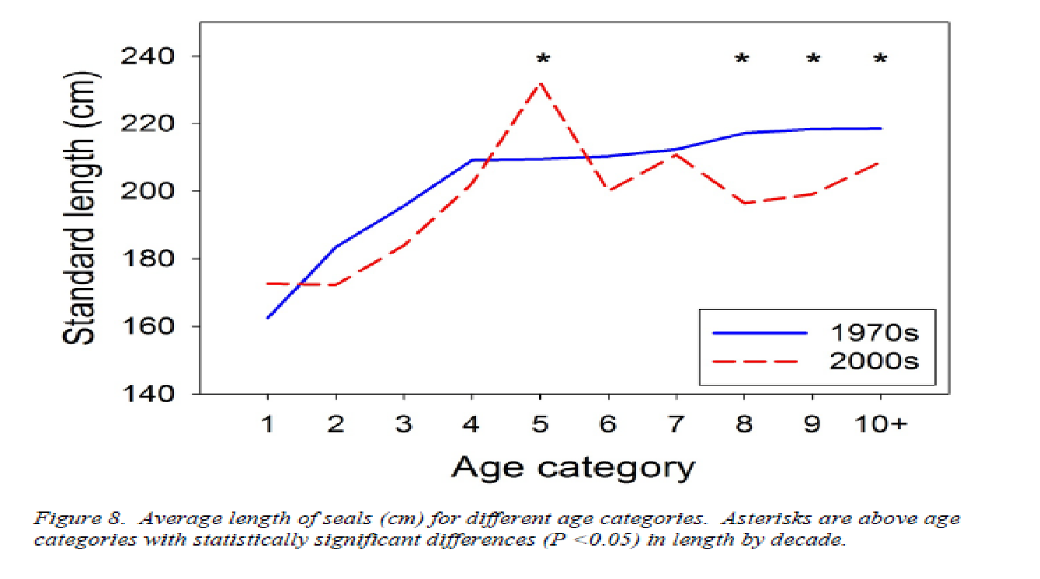

Spotted seals (Quakenbush et al., 2009)
Pupping occurs in March / April on the ice. Age at maturity is 3-4 yrs. Neonate: 0.8-0.9 m 7-12 kg; Weaning 1.1 m 36 kg; Adult 1.6 - 1.7 m 80-130 kg
average thickness ranged from 2.6 cm (SE=0.13) in June to 6.5 cm (SD=0.75) in December

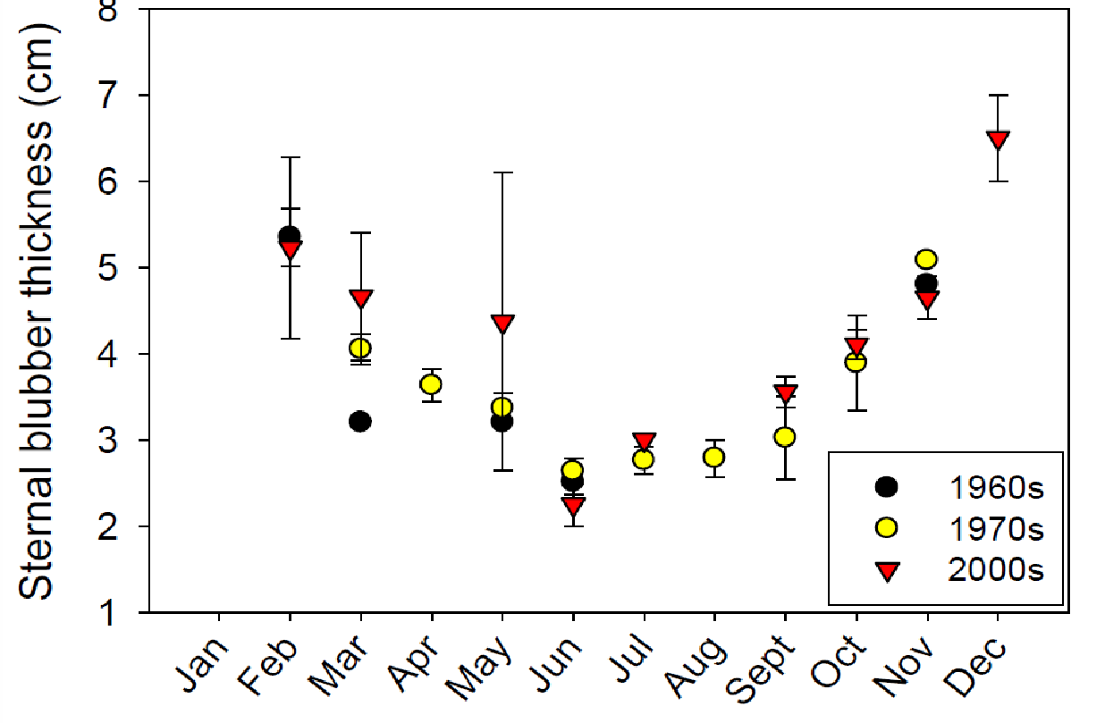

Figure 11. Mean sternal blubber thickness by month of sampling for seals three years of age or greater. Error bars represent one standard deviation.

Harbor seal (Phoca vitulina)
Harbor seal – 7-8 kg at birth; https://www.afsc.noaa.gov/nmml/species/species_harbor.php
Neonate: 0.7-0.9 m 9-15 kg; Weaning: 0.9m 20-29 kg; Adult 1.5-1.9 m 75-120 kg

More data about BC in (Cottrell et al., 2002)

COOK INLET BELUGA WHALES; COPIED FROM D. VOS THESIS. (Vos, 2003)
females with an estimated age of less than seven years and males with an estimated age of less than eight years were coded as juvenile. Age of first calving is estimated at 13 yrs (Brodie, 1971), (Burns and Seaman, 1986) (HEIDE-JØRGENSEN et al., 1994; Suydam, 2009)
Belugas a birth are approximately 5 ft (152 cm) and weight 150 lbs (63kg) (Mystic Aquarium web site). wild beluga populations have estimated that beluga calves average 1.6 m (5.2 ft.) and weigh about 80 kg (176 lb.). Beluga whale calves have been born and successfully raised at SeaWorld parks. The average size of SeaWorld-born beluga calves is 1.5 m (5 ft.) and 54 to 64 kg (119-140 lb.) (https://seaworld.org/en/animal-info/animal-infobooks/beluga-whales/birth-and-care-of-young).

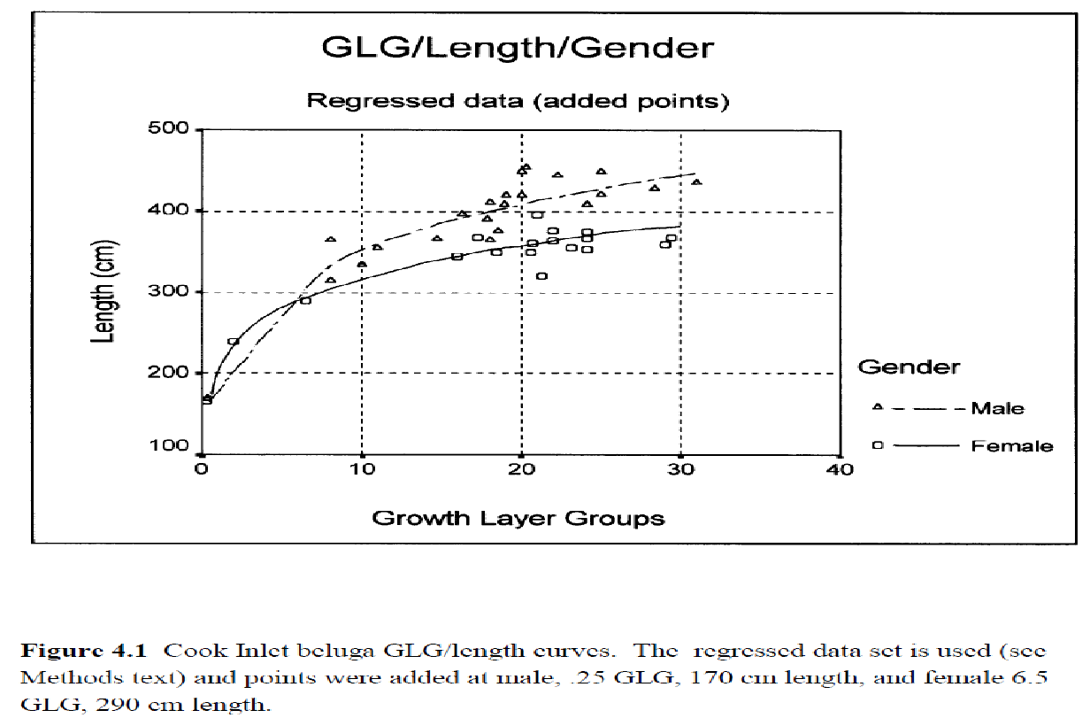
Figure 4.1 Cook Inlet beluga GLG/Length curves. The regressed data set is used (see Method text) and points were added at male, 0.25 GLG, 170 cm length and female 6.5 GLG 290 cm length.

Harbor Porpoise (Gaskin and Blair, 1977; Lockyer, 2003; Lockyer et al., 2001)
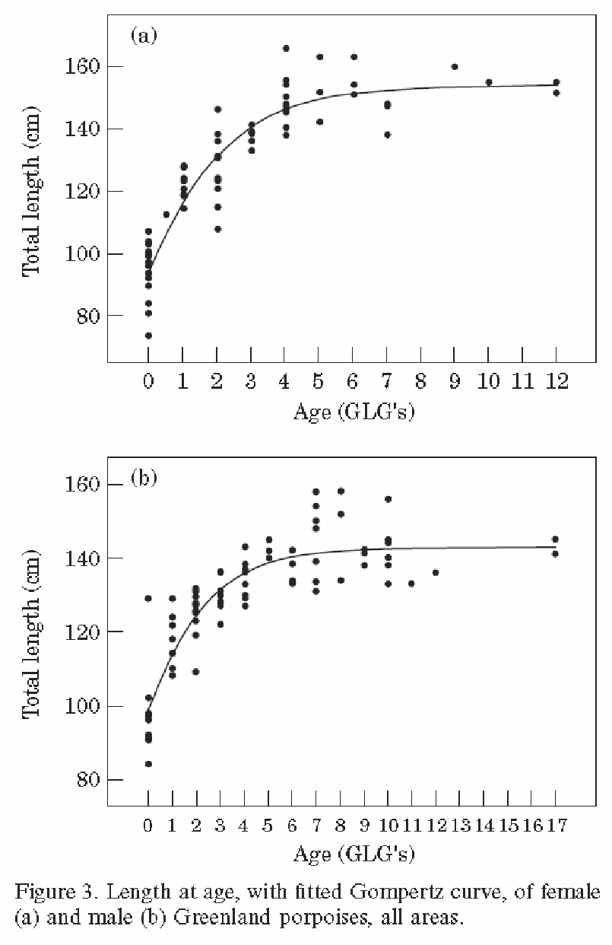
In Greenland: The switch from immature to mature appears to occur at 2 years in males with all male mature by 3 years. Maturation occurs at a length of 123 cm and all are mature at 130cm. The average age at sexual maturation is 2.45 yrs.
In females, the youngest sexually mature animal was at 3 yrs
Average age for sexual maturity in the North Pacific was 4.5 yrs. California males mature at 140cm and females at 142cm .
There appears to be a breeding season in August with hypertrophy of the testes at that time.

Dall’s porpoise (Ferrero and Walker, 1999)
Life history parameters were estimated for Dall's porpoise, Phocoenoides dalli, from biological specimens collected in the western Aleutian Islands, during 1981–1987. Of 2,033 males and 3,566 females examined, reproductive data were available for 1,941 males and 1,906 females; ages were determined for 813 males and 1,297 females. Female sexual maturity was based on the presence of one or more corpus on either ovary; 845 were sexually immature and 1,061 were sexually mature. Two estimates of female average age at sexual maturity (ASM) were 3.8 and 4.4 yr; average length at sexual maturity (LSM) was 172 cm. Males were considered sexually mature when evidence of spermatogenesis was detected; 1,136 were sexually immature and 805 were sexually mature. Two estimates of male ASM were 4.5 and 5.0 yr; LSM was 179.7 cm. Physical maturity was assessed for 246 males and 446 females by examining the degree of fusion in thoracic vertebral epiphyses. For both sexes, the average age at physical maturity was 7.2 yr. Average length at physical maturity was 202.6 cm for males and 192.7 cm for females. Average lengths of physically mature males (x̄= 198.1 cm, SE = 0.8566) and females (x̄= 189.7 cm, SE = 0.4002) were significantly different(P < 0.0001). Early postnatal growth was rapid in both sexes. A secondary growth spurt in both mass and length was characteristic for both sexes; the increase in length preceded the mass increase by 1–2 yr. Average length at birth (LOB) was approximately 100 cm; birth mass averaged 11.3 kg (SE = 0.0772). By the time the umbilicus had healed (<2 mo), the average length and mass had increased to 114.1 cm and 23.8 kg, respectively. Gestation period based on projections using LOB was 12 mo, but this was considered an overestimate. Calving was modal, centered in early July; an annual reproductive interval was indicated. Among the sexually mature females, 120 were pregnant, 55 were pregnant and lactating, 321 were pregnant with colostrum, and 33 were “resting.” By 3 July (95% CI =x̄ 1 d), 50% of births had occurred, during each of the seven years sampled. The ovulation rate was estimated at 0.914 ovulations per average reproductive year. Enlarged follicles and recent ovulations were observed in postpartum females in late July.
Killer Whale – From SeaWorld webcite https://seaworld.org/animal-info/animal-infobooks/killer-whale/physical-characteristics
A female killer whale will give birth every 3 - 5 years on average, to one offspring at a time. The gestation period usually lasts for around 17 months. They can give birth any time of the year.
A baby orca is called a calf, and they are about 8.5 feet (2.6 m) long and 265 to 353 lbs. (120 to 160 kg) at birth, according to Sea World.Nov 20, 2014
Both sexes reach sexual maturity around 10-18 yrs; Become phyisally mature about 6 years after sexual maturity (Brault and Caswell, 1993). (Sexual maturity around 13 yrs and physical maturity around 18.5 yrs for males according to Olesuik2005 (Olesiuk et al., 2005)). Max age for females is 80-90 yrs and 50-60 fo= 31 yrs males. Considered “juveniles” until age 15.5 yrs. Mean life expectancy for males - Females usually have their first calf around 14 yrs and become sexually quiescent after 345-45 yrs. 17 mo gestation.
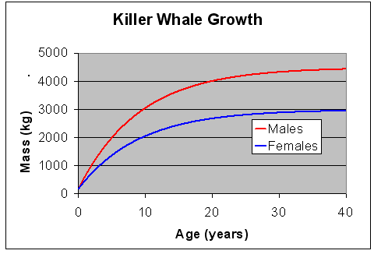
Southern resident Killer whales (Fearnbach et al., 2011)
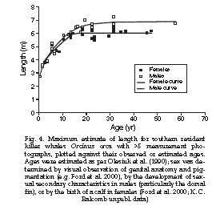
Captive killer whales: From Website: (Duffield and Miller, 1988)
length in cm | est. age in years
< 291 | < 1
291-328 | 1
329-366 | 2
367-404 | 3
405-442 | 4
443-480 | 5
481-518 | 6
519-552 | 7
553-590 | 8
591-628 | 9
Duffield, D.A. and K.W. Miller, 1988. Demographic Features of Killer Whales in Oceanaria in the United States and Canada, 1965-1987. Rit Fiskideildar. 11: 297-306.
In Pacific whales, growth is approximately linear, at a mean rate of 38 cm/yr up to 10-12 or 12-16 years of age, for females and males, respectively

Stejneger’s Beaked whale
According to Robert L. Brownell Jr. (pers. Comm. NOAA), they are around 225-230 cm at birth and around 335 to 340 cm around a year of age.
According to Tajima:The mean value for body length was 467 cm for adult males (n=18) and 486 cm of the adult females (n=21). Mean body weights: adult males was 886 kg (n=5) and adult females was 1,218 kg( n=2).
The body lengths of the 2 neonates were 191 cm and 195 cm. (Tajima et al., 2014).
A “neonatal” Stejneger’s that beached in Japan was 242 cm long (Shindo et al., 2008).
Humpback Whale (Megaptera novaeangliae)
Mean length for newborns is 3.96 – 4.57 m (13-15 ft);
Animals at independence are typically between ~ 8 - 10m. Sexual maturity at approx. 5 yrs of age
Adult female – 15 m ; Adult male 13.5 m; Newborn 4.2 m; Weight 30,000 to 48,000 kg for Adult
Unconfirmed average life expectancy – 40-50 yrs with max up to 80 yrs
(Clapham et al. 1999; N. Pac Universities Marine Mammal Research Consortium:
http://www.marinemammal.org/biology/humpback-whales/). (http://www.marinemammal.org/biology/humpback-whales/
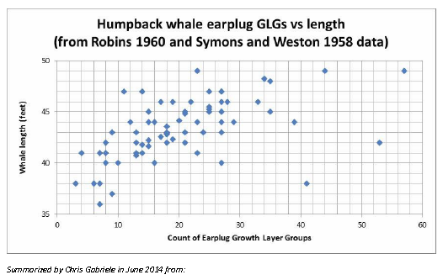
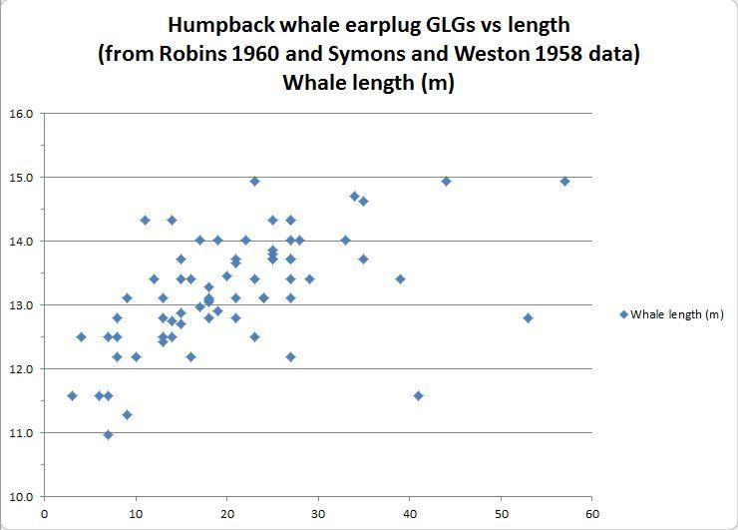

Steller sea lion
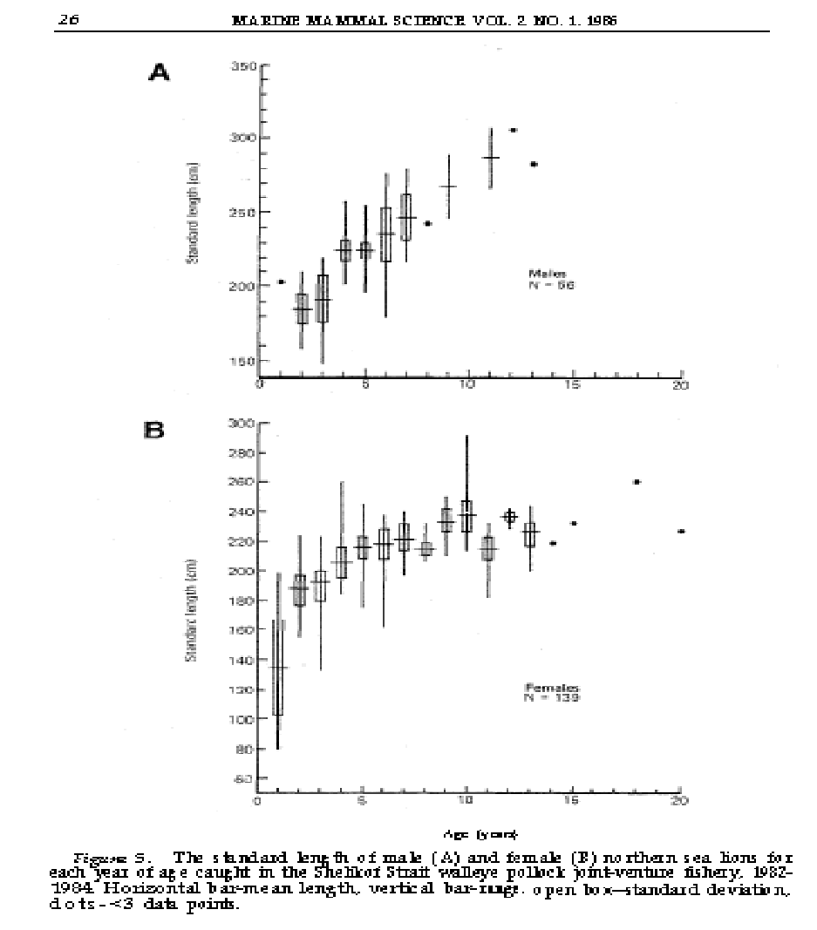
(Loughlin and Nelson, 1986)
Males may grow to 11 feet (3.25 m) in length and weigh almost 2,500 pounds (1120 kg). Females are much smaller and may grow to nine feet (2.9 m) in length and weigh 1,000 pounds (350 kg). (MMC WEBSITE http://www.marinemammalcenter.org/education/marine-mammal-information/pinnipeds/steller-sea-lion/?referrer=https://www.google.com/
Pups typically are born on islands from mid-May to mid-July and weigh 35-50 pounds (16-23 kg)
Age Classes
Age Class | Male | Female
Pup | 1 -2 years | 1 -2 years
Juvenile | 2-6 years | n/a (classified as subadults)
Subadult | 6-9 years | 2-6 years
Adult | 9+ years | 7+ years

Fin whales
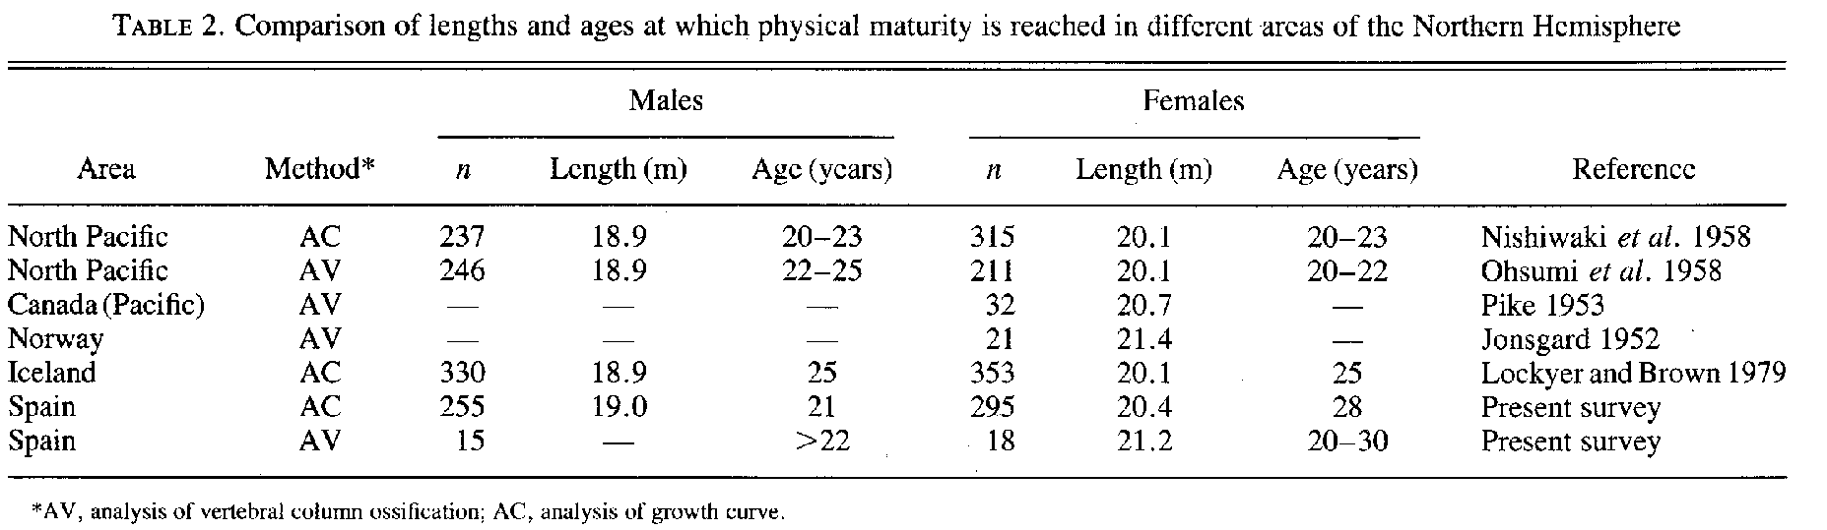
Males reach 95% asymptotic length at 9 and females at 13 yrs. Both physical maturity at 20-30 yrs.
Gestation last >11 mo; weaning takes place at 6-7 months and the calf reaches length of about 12 m. (Aguilar and Lockyer, 1987)
Expected blubber thickness: DAX-45mm; LAX = 60 mm; BDF = 110 mm - (Lockyer, 1986)

GREY WHALES updated from Denise Greig, PhD 9/16/20 NR

 | Length in meters
 | Rice & Wolman 1971 | Sanchez Pacheco 1998 | Sumich 1986 | Jones and Swartz 1984 | Calambokidis/SWFSC survey data | Norman et al 2000 | 1999/2000 UME | Suggested Size Categories
Calf (0-12 months) | 8.5 at weaning in August | 3.4-6.5 | Up to 9, most <8 | 3-8.99 | 7.1 in April | < 8 | <8 | <7- 8 (supported by short baleen < 25 cms at longest plate, small barnacles)
Yearling (12-24 months) |  | 6.6-9.5 |  | 9-10.9 grouped immatures together | 8.5 southbound | 8-8.9 | 8-8.9 | 8-9 (but consider other features such as baleen length, larger barnacles, strand location, and time of year)
Juvenile/subadult (24 months- sexual maturity) |  | >9.6 |  |  |  | 9-11.9 | 9-11.9 | 9-11.1 male  9-11.7 female
Adults (8 years) (male) | 11.1 |  |  | > 11.1 |  | >12 | >12 | > 11.1
Adults (8 years) (female) | 11.7 |  |  | > 11.1 |  | >12 | >12 | > 11.7

Sanchez Pacheco bases ages on frequency distribution of dead animal sizes in the lagoons, with each peak a different age class, (could be looking at fetus/abortions in the calf class??).
Sumich assumes gray whales lay 2 rings in ear plug in first year, one per year after that.
Direct observations of growth in two known age rehabilitating gray whales are GiGi (8m at 1 year) and JJ (9m at 1 year), showing diet influences growth, see Sumich 2001b
References
Agbayani, S., Fortune, S.M.E., and A.W.Trites. 2020. Growth and development of North Pacific gray whales (Eschrichtius robustus). Journal of Mammalogy 101(3):742-754.
Bradford A.L, Weller, D.W., Burdin, A.M., Brownell, R.L. 2011. Using barnacle and pigmentation characteristics to identify gray whale calves on their feeding grounds. Marine Mammal Science 27(3):644-651.
Gulland, F., H. Pérez-Cortés M., J. Urbán R.et al. Eastern North Pacific Gray Whale (Eschrichtius robustus) Unusual Mortality Event, 1999-2000: A Compilation. U.S. Dep. Commer. NOAA Tech Memo NMFS-AFSC-150. 33p.
Jones, M.L. and S.L. Swartz, 1984. Demography and phenology of gray whales and evaluation of whale-watching activities in Laguna San Ignacio, Baja California Sur, Mexico. in the Gray Whale” eds MLL Jones, SL Schwartz, S. Leatherwood.Academic Press, San Diego.309-374.
Norman, S. A., M. M. Muto, D. J. Rugh, and S. E. Moore. 2000. Gray whale strandings in 1999 and a review of stranding records in 1995-1998. Final Draft, Unusual Mortality Event Report to the National Marine Fisheries Service. Unpubl. doc. submitted to Int. Whal. Comm. (SC/52/AS5). 36 pp.
Rice, D.W., and A.A. Wolman. 1971. The Life History and Ecology of the Gray Whale (Eschrichtius robustus). American Society of Mammalogy Special Publication No. 3. 142 p.
Sánchez Pacheco, J.A. 1998. Gray whale mortality at Ojo de Liebre and Guerrero Negro lagoons, Baja California Sur, Mexico: 1984-1995. Mar. Mammal Sci. 14(1):149-155.
Sumich, J. 1986. Growth in young gray whales (Eschrichtius robustus). Marine Mammal Science, 2(2):145-152
Sumich, J. 2001a. Growth of baleen of a rehabilitating gray whale. Aquatic Mammals 27:234-238
Sumich, J. 2001b. Growth of two captive gray whales. Aquatic Mammals 27:231-233.
Sumich, J.L., Blokhin, S.A., Tiupeleyev, P.A. 2013. Revised estimates of foetal and post-natal growth in young gray whales (Eschrichtius robustus). J. Cetacean Res. Manage. 13(2):89-96.

Kate Savage
Species | Color | Adult size | Flippers / fluke | Dorsal fin | Throat grooves | Other
Gray whale | dark slate gray with gray-white patterns. White patches usually barnacles or lice | 14.9 m (49'), females usually larger than males | deeply notched | none, just dorsal ridge | 2-7 short throat creases | 300 plates short, blonde baleen, LS = 55-70 years
Both sexes weigh up to 30-40 tons. The gray whales flukes or tail can span up to 10 feet.
Grays whales live about 40 to 60 years, some can live 70 years.
Aging through the lens,
Mean body lengths of gray whale calves were found to increase linearly from 4.6 m at birth to 7 m by weaning at six mo. After weaning, rates of length increase diminish, with calves reaching 8 m by one yr of age and 9 m by two yr. Evaluations of the weights of nine gray whales as functions of their measured lengths and girths reduce the emphasis placed on fast‐induced seasonal variations in girth by Rice and Wolman (1971). From birth weights of just under one metric ton, calves double their weights by three mo of age and double again by weaning at six mo (Sumich, 1986).

