STRANDING NETWORK SSL NECROPSY REPORT

ID Number: __________Location: __________ (Lat;Long)________________
Reported by: _________________ Contact info:_____________________________________
Date found: _____________Date recovered: ____________ Necropsy Date: ____
Species: Age: Sex: M F Unknown
Prosectors: Contact info: _________________________ Weather info:___________________________________________________________________
Human Interaction Forms? ◻; Chain of custody forms: ◻; Level A forms filled out ◻
Brief History:

Gross Diagnoses:

MEASUREMENTS (cm unless indicated)
Weight (kg) ____________ estimate / actual (circle one)
Standard length ____________ cm / inch / feet?
Curvilinear length ____________ cm / inch / feet?
Girth: Axillary (flipper pit) ____________ cm
Girth: maximum ____________ cm
Blubber thickness (mm) (see later diagram for sites):
Dorsal flank (SSLs) ___________mm( dorsal 3cm above hips, 2cm right of spine)
Dorsal Axillary (DAX) ___________mm
Lateral at Axilla (LAX) ___________mm_
Vent Midline axilla (VAX)___________mm
Xyphoid ___________mm
1

Tooth Measurements:

Diastema (DIAS) __________mm (distance between upper premolars and last molar)

RUCanine length (caudal) = CTL__________mm width ___________mm
Age = (−3.0112 +[0.6726 * CTL]+[0.4965 * DIAS]) - Only applies up to 24 months and the result is in months.
Eruption pattern: (adult vs deciduous teeth) (I = incisors; P = premolars M = molars)
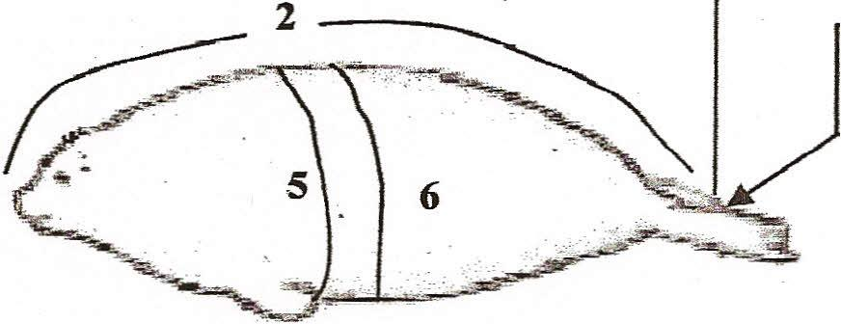
EXTERNAL EXAMINATION
CARCASS CLASSIFICATION: |  | BODY CONDITION:
Code 2 Fresh |  | 1 Robust
Code 3 Fair (decomposed organs intact) |  | 2 Good
Code 4 Poor (advance decomposition) |  | 3 Average
Code 5 Mummified |  | 4 Poor
Was the carcass frozen ?? YES NO |  | 5 Emaciated

GROSS NECROPSY FINDINGS:
Physical Exam (general condition, lesions, deformities, appearance, color): (See lesion form page 3.) COLLECT WHISKERS OR WHOLE CHEEK (SSLS) NASAL OR ORAL SWABS IF FRESH

Primary incision (fat stores,carcass condition, etc): COLLECT BLUBBER and SKIN.

Body cavities (fluid?):

Musculoskeletal (color of muscle, appearance of joint fluid): MUSCLE FOR MUSEUM FROZEN AND FORMALIN

Respiratory (foam, fluid, texture and color of lungs, parasites?); SAMPLES OF LUNG FROZEN AND FORMALIN

Cardiovascular: STERILE HEART BLOOD; HEART FOR MUSEUM, FROZEN AND FORMALIN

Lymphoid: SAMPLE LYMPH NODES, SPLEEN - FROZEN AND FORMALIN

Endocrine: ADRENAL GLAND, THYROID, PITUITARY-FROZEN AND FORMALIN

Urinary: COLLECT URINE (HABS), KIDNEY FOR MUSEUM, FROZEN AND FORMALIN

Liver: (bile, parasites, color, texture); LIVER SAMPLES; BILE IF FRESH; FOR MUSEUM, FROZEN AND FORMALIN.

Digestive: (serosal surface, content, mucosal surface, parasites) ; FECES FOR HABS

Reproductive; TESTES, OVARY, UTERUS - FROZEN AND FORMALIN

Nervous / sensory: BRAIN, PERIPHERAL NERVES - FROZEN AND FORMALIN.

DISPOSITION:
SAMPLES SUBMITTED IMMEDIATELY AND WHERE

ANCILLARY DIAGNOSTICS:

COMMENTS (CAUSE OF DEATH, INTERPRETATIONS):

HOW DID YOU TAKE YOUR TOXICOLOGY SAMPLES?:
Ziplocs / Foil / Acetone-cleaned Foil / Teflon / Whirlpak / I-Chem jars
Other__________________________________ Rinsed tissues with: _______________________________
Type of gloves (circle): latex vinyl powder-free nitrile

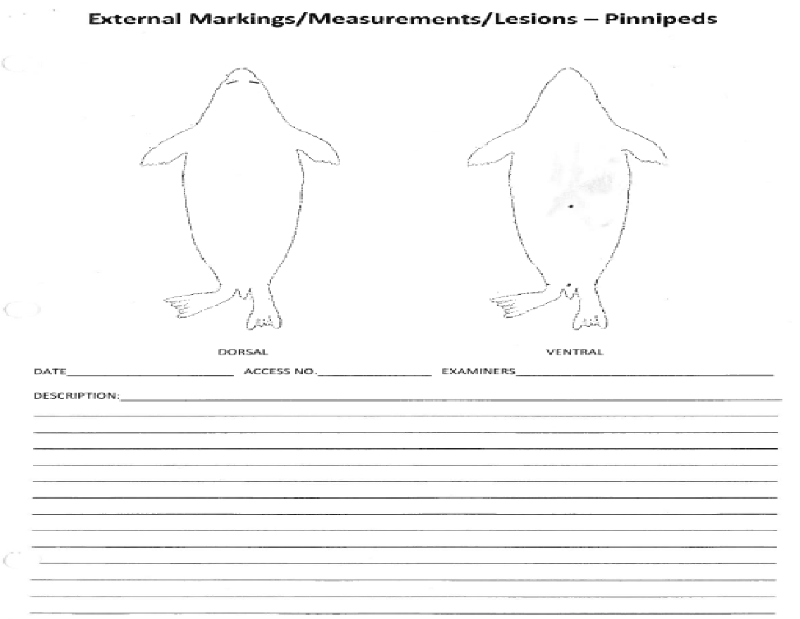
Dorsal axillary blubber thickness (mm)
Ventral axillary blubber thickness (mm)
Lateral axillary blubber thickness (mm)
Biopsy blubber thickness (mm)

Classification of Carcass condition:
Code | Definition | Gross Appearance | Specimen collection
1 | Live |  | Morphometrics, blood, biopsies, urine, infectious diseases, diagnostic imaging
2 | Freshly dead “edible” | No bloating; minimal drying and wrinkling of epidermis (in cetacean and manatees or dermis and epidermis in pinnipeds and otters); minimal wrinkling and change of eyes and mucous membranes; muscles firm; blubber firm and white or yellow; internal organs intact; liver still with physical integrity | All types of specimens should be collected
3 | Moderate decomposition | Slight bloating with tongue and penis protruding; some skin sloughing and cracking; eyes sunken; blubber may be blood tinged; muscles soft; all internal organs including liver still have gross integrity but are soft and friable | Morphometrics, gross path, parasitology, genetics, life history, +/- histo on lesions.
4 | Advanced decomposition | Bloated; missing patches of epidermis and hair; internal organs show lack of integrity and are extremely friable; blubber with gas pockets and pooled oil | Morphometrics, gross path, parasitology, genetics, life history
5 | Severe decomposition | Mummified; skeletal | Limited morphometrics, age, skeletal pathology, genetics
Notes on sampling:
PHOTOS: Take lots of photos. Include the animal ID and a measuring device in the photo. Take notes on photos under the system descriptions, or photo numbers in the table. Unknowns a good thing to do is take a photo, label it unknown 1,2,3,…. And then tag a piece for histo.
Archive samples: In general put in whirlpak or cryovials (or ziplock and squeeze out all air) and freeze in as cold as possible (ultracold is best – otherwise regular freezer)
Disease samples: Try to collect as aseptically as possible. You can collect these samples first, use a fresh scalpel blade or flame clean if possible, store in whirlpak. Just do the best you can and if they are contaminated, take as big a sample as will fit in a small whirlpak.
Toxicology samples: Collect as cleanly as possible and try to rinse the blade between samples with water and high grade ethanol or isopropyl if possible. A fist size or slightly larger sample can be trimmed down to make up for any contamination in taking the sample. Put in acetone washed Teflon, foil or an I-chem jar if they can be taken cleanly. Then into a whirlpak (or ziplock if you run out of whirlpaks). Kidney and one liver samples also goes directly into a whirlpak without foil.
HABS (harmful algal bloom toxins): best samples are urine, feces, stomach content. If there is no urine, pericardial fluid is also very good. On fetuses, stomach content is very good to use. Preg female, collect amniotic fluid. Minimum of 5 ml of sample. Analyses can be done at the HAB NOAA lab in Seattle ELIZABETH FRAME KATHI LEBEVRE.
Histopathology: NO NOT FREEZE THESE SAMPLES. Samples should be in 10% neutral buffered formalin in a ratio of 1 part tissue to 10 parts formalin. If you don’t have big enough containers, the formalin can be switched out after a day to help with fixation. Samples should be 0.5 to 1 cm thick.
Fetuses: Stomach content is an important sample in fetuses. Do all the same sample collections plus the following for stomach content: pull out some stomach content (with sterile needle and syringe), put in a few cryovials. 3-4 1 or 2 ml cryovials for culture work and 2 - 5 ml cryovials for biotoxins. If you have bacterial media or culturettes, you can take those too. These would be best to submit the swabs to the lab fresh, but if you can’t, freeze at ultracold. If you don’t have these sampling items, tie off the stomach and freeze in a whirlpak.
Placentas: Very valuable samples. Take formalin fixed samples, samples in whirlpaks (three 4 oz), freeze back entire if possible, if not, weigh and measure after taking samples.
Parasites: External parasites (70% ethanol-ETOH), Nematodes (70% ETOH or formalin). Put acanthocephalans in distilled water, refrigerate over night, then fix in formalin or 70% ETOH. Cestodes?
Blubber: If people are doing studies with blubber biopsies in live animals, they may want pieces of the biopsy sites. If so, take a 5cm square (skin to muscle layer) sampled from the dorsal side of animal 2-3cm to the right of the vertebral column, 2-3cm anterior to the pelvic girdle. For Toxicology, AMMTAP and archive, collect from ventral midline at the xiphoid.
Whisker: Easiest -- Freeze cheek with all whiskers intact. Or pull longest whisker on left side and put in paper envelope (SSL). These are for stable isotopes
Label each sample with Animal ID, tissue type and Date collected; DOUBLE BAG AND LABEL
