**STRANDING NETWORK SEAL NECROPSY REPORT**

ID Number: __________Location: __________ (Lat;Long)________________

Reported by: _________________ Contact info:_____________________________________

Date found: _____________Date recovered: ____________ Necropsy Date: ____

Species: Age: Sex: M F Unknown

Prosectors: Contact info: _________________________

Volunteers: *Please provide name, contact info, and hours worked* _______________________________________________________________________________________________________________________________________________________________________________________________________________________________________

_____________________________________________________________________________

Weather info:___________________________________________________________________

Human Interaction Forms? 🞎; Chain of custody forms: 🞎; Level A forms filled out 🞎

Brief History:

Gross Diagnoses:

**MEASUREMENTS** (cm unless indicated)

Weight (kg) ____________ estimate / actual (circle one)

Standard length (1) ____________ cm / inch / feet?

Curvilinear length (2) ____________ cm / inch / feet?

Girth: Axillary (flipper pit) (5) ____________ cm

Blubber thickness (mm) (see red marks below):

Xyphoid ______mm DAX mm LAX mm VAX mm

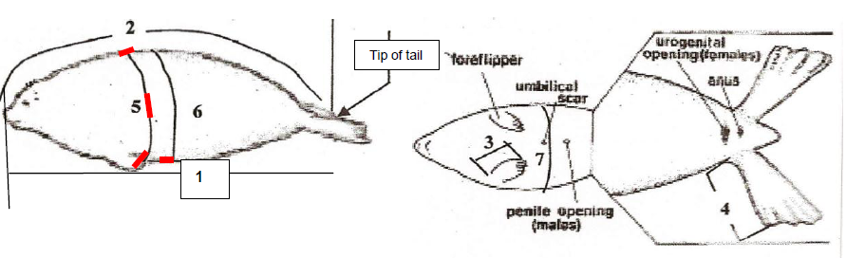

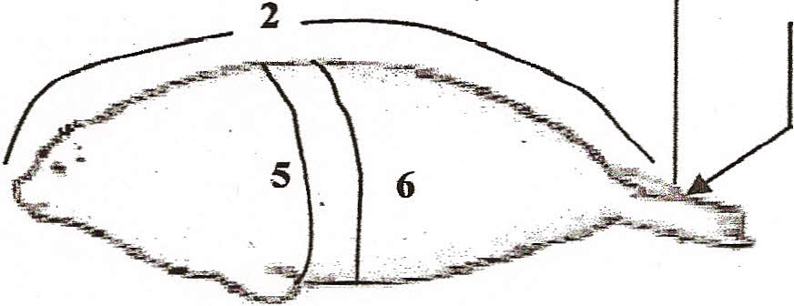**EXTERNAL EXAMINATION**

**1**

|  |  |  |
| --- | --- | --- |
| **CARCASS CLASSIFICATION: (circle)** |  | **Body Condition:(circle)** |
| Code 2 Fresh |  | 1 Robust |
| Code 3 Fair (decomposed organs intact) |  | 2 Good |
| Code 4 Poor (advance decomposition) |  | 3 Average |
| Code 5 Mummified |  | 4 Poor |
| Was the carcass frozen ?? YES NO |  | 5 Emaciated |

**GROSS NECROPSY FINDINGS:**

|  |
| --- |
| Physical Exam (general condition, lesions, deformities, appearance, color): (See lesion form page 3.) COLLECT CLAW; NASAL OR ORAL SWABS IF FRESH |
| Primary incision (fat stores,carcass condition, etc): COLLECT BLUBBER and SKIN. |
| Body cavities (fluid?): |
| Musculoskeletal (color of muscle, appearance of joint fluid): MUSCLE FOR MUSEUM. |
| Respiratory (foam, fluid, texture and color of lungs, parasites?); SAMPLES OF LUNG |
| Cardiovascular: STERILE HEART BLOOD; HEART FOR MUSEUM |
| Lymphoid: SAMPLE LYMPH NODES, SPLEEN |
| Endocrine: ADRENAL GLAND, THYROID, PITUITARY |
| Urinary: COLLECT URINE (HABS), KIDNEY |
| Liver: (bile, parasites, color, texture); LIVER SAMPLES; BILE IF FRESH |
| Digestive: (serosal surface, content, mucosal surface, parasites) ; FECES FOR HABS |
| Reproductive; TESTES, OVARY, UTERUS |
| Nervous / sensory: BRAIN, PERIPHERAL NERVES. |

**COMMENTS (WHY DID THE ANIMAL DIE / STRAND / WAS ILL?):**

**If you could sketch on this schematic any areas of lesions**



Lateral axillary blubber thickness (mm)

Xiphoid blubber thickness (mm)

Dorsal axillary blubber thickness (mm)

|  |
| --- |
| Bearded seal - Neonate: 1.3 m 35 kg; Weaning: 1.5 m 85 kg; Adult 2.1 - 2.5 m 230 = 360 kg |
| Harbor seal - Neonate: 0.7-0.9 m 9-15 kg; Weaning: 0.9m 20-29 kg; Adult 1.5-1.9 m 75-120 kg |
| Spotted seal - Neonate: 0.8-0.9 m 7-12 kg; Weaning 1.1 m 36 kg; Adult 1.6 - 1.7 m 80-130 kg |
| Ringed seal - Neonate 0.6-0.7 m 4-4.5 kg; Weaning 0.8 m 9-16 kg; Adult 1.2-1.5 m 60-100 kg |
| Ribbon seal - Neonate: 0.8-0.9 m 9-11 kg; Weaning 0.9-1.1 m 22-30 kg; adult 1.5=1.8 m 80-145 kg |

**Classification of Carcass condition:**

|  |  |  |  |
| --- | --- | --- | --- |
| Code | Definition | Gross Appearance | Specimen collection |
| 1 | Live |  | Morphometrics, blood, biopsies, urine, infectious diseases, diagnostic imaging |
| 2 | Freshly dead “edible” | No bloating; minimal drying and wrinkling of epidermis (in cetacean and manatees or dermis and epidermis in pinnipeds and otters); minimal wrinkling and change of eyes and mucous membranes; muscles firm; blubber firm and white or yellow; internal organs intact; liver still with physical integrity | All types of specimens should be collected |
| 3 | Moderate decomposition | Slight bloating with tongue and penis protruding; some skin sloughing and cracking; eyes sunken; blubber may be blood tinged; muscles soft; all internal organs including liver still have gross integrity but are soft and friable | Morphometrics, gross path, parasitology, genetics, life history, +/- histo on lesions. |
| 4 | Advanced decomposition | Bloated; missing patches of epidermis and hair; internal organs show lack of integrity and are extremely friable; blubber with gas pockets and pooled oil | Morphometrics, gross path, parasitology, genetics, life history |
| 5 | Severe decomposition | Mummified; skeletal | Limited morphometrics, age, skeletal pathology, genetics |

**Notes on sampling:**

**PHOTOS:** Take lots of photos. Include the animal ID and a measuring device in the photo. Take notes on photos under the system descriptions, or photo numbers in the table. Unknowns a good thing to do is take a photo, label it unknown 1,2,3,…. And then tag a piece for histo.

**EASIEST APPROACH: FREEZE ONE, FIX ANOTHER.**

**Histopathology: NO NOT FREEZE THESE SAMPLES.** Samples should be in 10% neutral buffered formalin in a ratio of 1 part tissue to 10 parts formalin. If you don’t have big enough containers, the formalin can be switched out after a day to help with fixation. *Samples should be 0.5 to 1 cm thick.*

**RNALater:** **ONLY FOR EXTREMELY FRESH (hours dead!) SAMPLES.** Put tiny pieces of liver, lymph node and skin lesion into RNAlater vial. This can be stored at room temp, regular freezer or refrigerator for short periods of time. After about 24 hours, the liquid should be poured off, and sample stored frozen as cold as possible.